# Web/Mobile Programming- Project Increment

# Project Title: E-commerce Website

Group No: 14

Team Members:

1. Mani Sai Gundumogula; mgy3v@umsystem.edu
2. Bhanu Manoj Bade; bbrry@umsystem.edu
3. Sai Saranya Vipparla; svv7x@umsystem.edu
4. Nagendra Babu Dosapati; Nbdh3c@umsystem.edu

**GitHub Link:**

Front End : <https://github.com/bhanumanojbade/web-project>

Back End : <https://github.com/bhanumanojbade/web-project-backend>

Presentation : <https://github.com/bhanumanojbade/web-project/tree/main/Presentation>

Video : <https://github.com/bhanumanojbade/web-project/tree/main/Video>

**Introduction:** Our major target demographic is small-business entrepreneurs. Our software will help them grow and improve their company. They will be able to reach the largest number of potential consumers by using our application. For example, in the summer, restaurant sales from walk-in visitors are $7000, but in the winter, when it snows, that number reduces to half, or even 20%. In exchange for 20 percent of the whole purchase, our program will help small business owners sustain sales during this challenging period. This will assist delivery drivers since they will be able to earn money by delivering orders to customers.

**Background:** Today, everyone uses an e-commerce website every day to buy something from the comfort of their home. Therefore, we are trying to create an e-commerce website where end users can buy products using a web programming language. On our website, users can view products on the main screen, search for the product they need, add it to their shopping cart, and pay for the product to be delivered to the desired address.

**Proposed Idea:** E-cart is a product delivery software that allows users to order their favorite items online. It is a user-friendly and trustworthy program that even non-technical folks can use. Both users (customers and vendors) will gain from this software, as well as the business of numerous stores.

**Methodology:** We are using React JS as Front end and Back end also.

When user clicks on the sign up button they can have the ability to register by filling their details. Once the signup is successful the details are stored in the MongoDB through sign up API.

When user tries to sign in the details of the user are authenticated using the sign-in API.

For displaying the products we have built an api and deployed it in Heroku. the product details are stored in mongo DB and when user enters the product screen the API fetches the products and displays it to the user.

All the API's are deployed into Heroku.

Through PayPal developer portal we are able to get the PayPal test API And we integrated it into our payment page.

**Features**:

1. Self-Registration: Users will be able to signup themselves using the signup page.
2. Once the user signup is successful, they will be able to login into the website.
3. The Search bar is to search for all the available products.
4. Once the user hovers on a product, the product will be visible in the foreground.
5. To display details about the product, the details of the products will be visible.
6. User can add multiple products to the cart.
7. User can use Paypal to proceed with the payment.

**Results & Evaluation:**

1. User login & Sign up Page: User can enter their login details to see and add the products in to cart.

1. If the User doesn’t exists / Invalid credentials, then there will be an error message saying that User doesn’t exists.

Upon Login user can see the list of products that are available on the website for purchase.

1. User can search for the products they wish to buy. Here in this below screen we have search for apple, so all the products related to apple will show up.

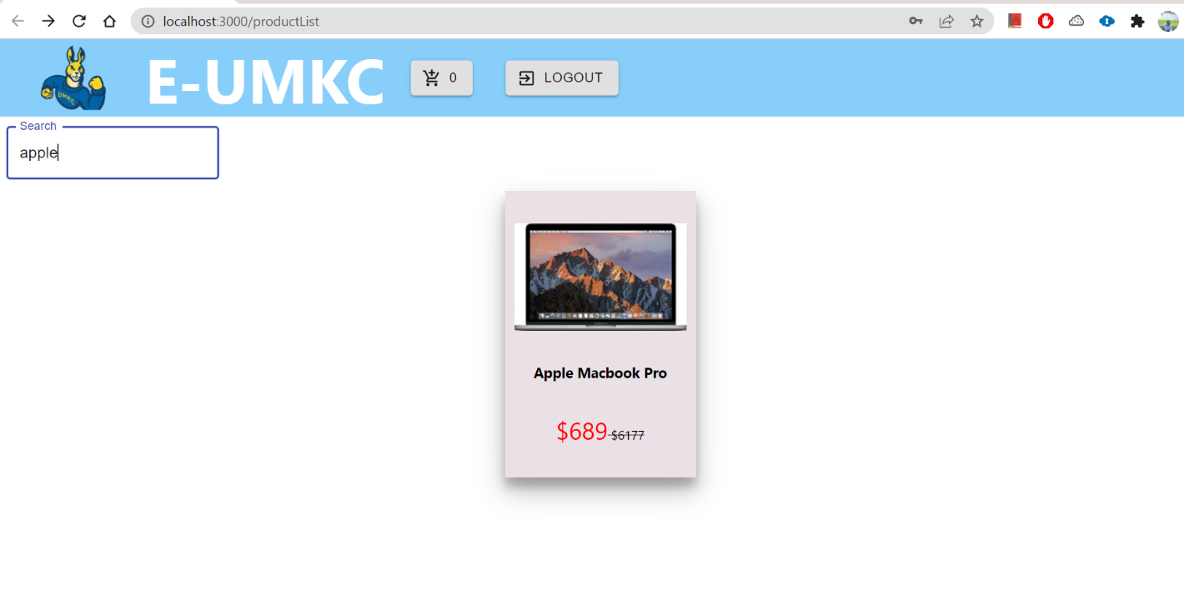

1. Product Selection: When the user clicks on the product, details about the particular product will be visible on the screen. User can add all the products they wish to purchase by adding them to cart. Graphical user interface

   Description automatically generated
2. Add to cart: To add a product to cart we need to click on Add-To-Cart button.

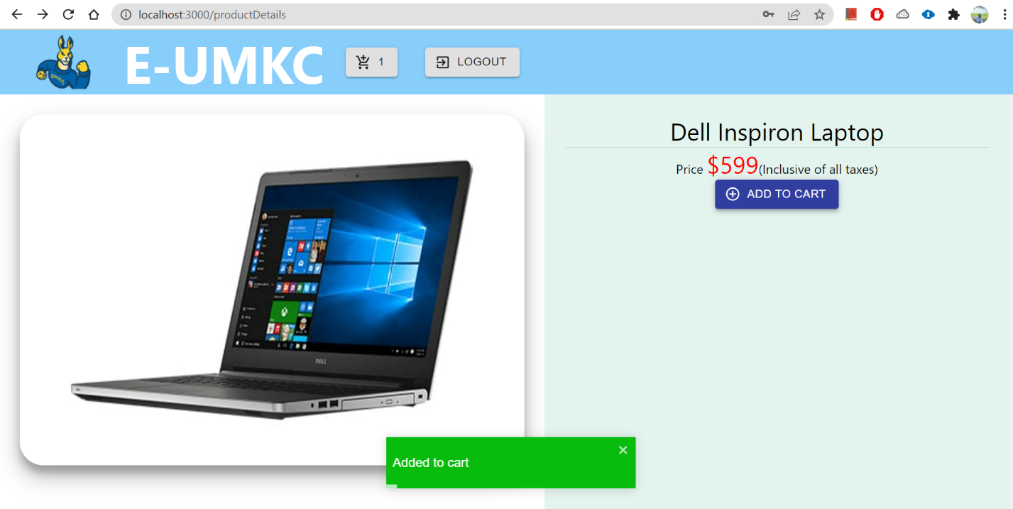

1. List of products added to cart: We have added two products to cart and clicked on cart symbol to see all the products in cart. Also, if we look deeply in to the cart symbol we can see the number of products available in cart.

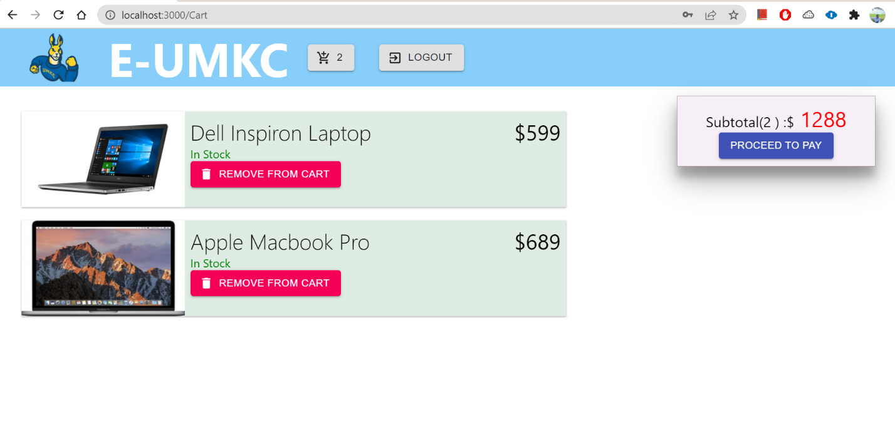

1. Remove from Cart: If the user wish to remove any products, they can simply click on the remove from cart button beside the respective product and the product will be removed from cart.

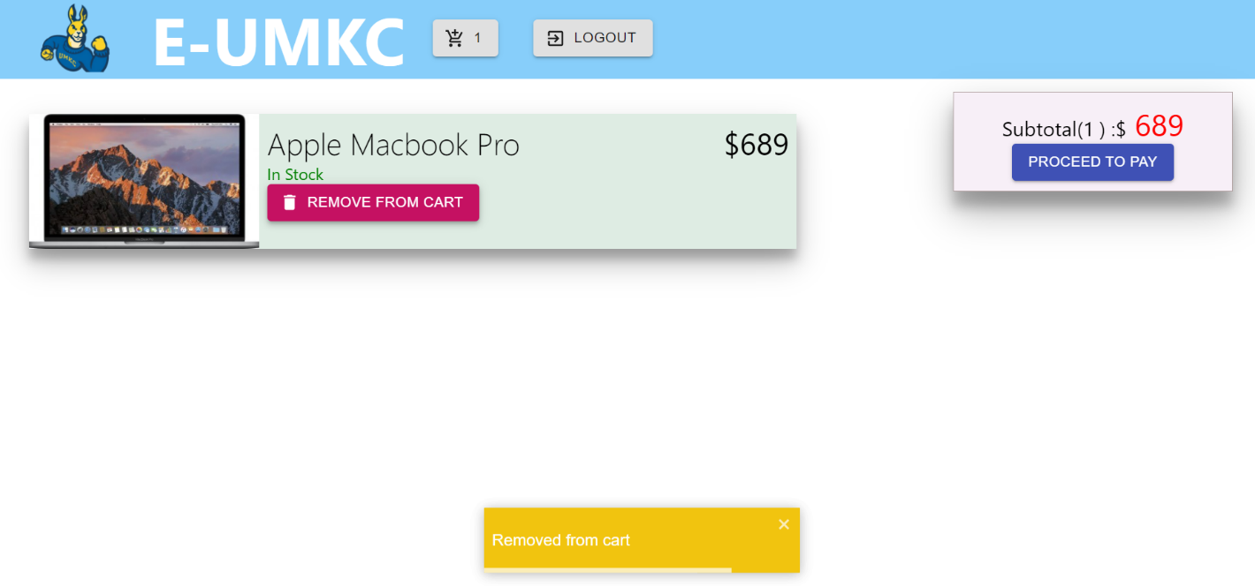

1. Proceed to Pay (Place your order): Once everything is good, user can proceed for payment by clicking on proceed to pay button.

1. When the user clicks on the LOGOUT button, then user will be logged out of the session and taken back to the login screen.

**Conclusion:** An e commerce website is created where users will be able to signup & login to search for the products to purchase all the available products with multiple quantities using Paypal, Debit & Credit card.

**Working Screenshots from project:**

**Work Distribution:**

Login/Signup API and Products list API -by Mani Sai and Nagendra   
Backend deployment by Manoj and Saranya

Mongodb(atlas) & storage in cloud - Mani Sai, Saranya, Nagendra, Manoj

**References:**

To understand the HTML: https://www.w3schools.com/html/default.asp

To have knowledge about JavaScript:

https://developer.mozilla.org/en-US/docs/Web/JavaScript/Guide/Introduction

To build and use APIs using NodeJS:

https://nodejs.org/en/docs/

To know more about how a payment interface works:

https://developer.paypal.com/docs/online/

https://razorpay.com/docs/

Regarding installing and managing databases:

https://docs.mongodb.com/guides/

Understanding more about e-commerce website development:

https://webflow.com/blog/ecommerce-website-development